
  - MyAccount Download Section / J905596 Veritas Press, LLC

Functional Requirements Document (FRD)

Copyright© 2017, Oracle and/or its affiliates. All rights reserved.
Any reproduction or distribution of any part of this document without the prior written permission of Oracle + NetSuite is strictly prohibited.
The information included in this document is confidential and proprietary information of Oracle + NetSuite.
Version: January 12, 2015

Oracle + NetSuite
2955 Campus Drive, Suite 100
San Mateo, CA. 99403-2511

Project Information
Customer Name (Number) | Veritas Press, LLC
Job Name (Number) | J905596
Document Owner | Piyush Kayastha
Solution Architect | Ilan Daniele
Project Manager | Billy Flores

Document Version History
Rev | Date | Author(s) | Change Summary
1.0 | 02/17/2023 | Piyush Kayastha | Initial Draft
1.1 | 02/17/2023 | Ilan Daniele | Added Few Notes
1.2 | 2/21/2023 | Piyush Kayastha | Responses provided
1.3 | 3/9/2023 | Piyush Kayastha | Additional feedback

Business Requirements
After someone purchases an item that is considered "digital", they want the URL to the file to be shown on the sales order line item. The customer must have access to the URL via their Purchase History and on the email confirmation of their order. This brought on the customer requirement around adding a section to My Account touchpoint of SS4C website to include a way for their customers to view Download Items they have purchased and to be able to download those items from within that My Account section.

Solution Overview
- Create up to one (1) page view on the MyAccount section to list Downloadable Items purchased by the user where we’ll list:
  - Date
  - Item Purchased
  - Description
  - Link (URL) (era un field que no estaba correcto)
Evaluar si es viable.
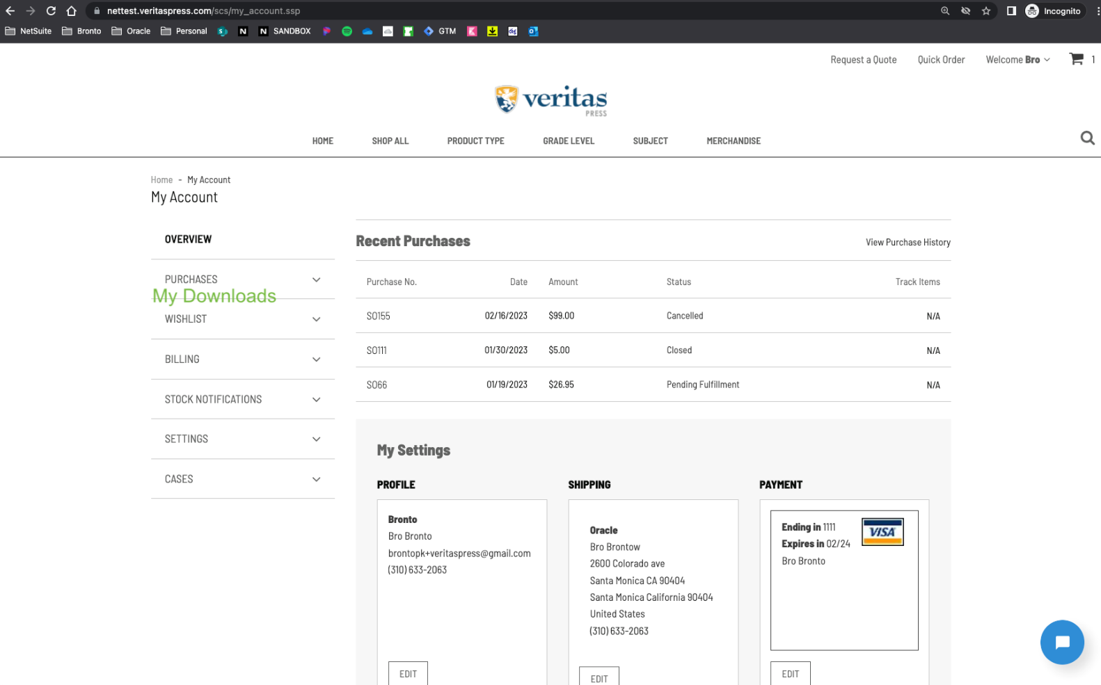
The content of the section can look like the following content:
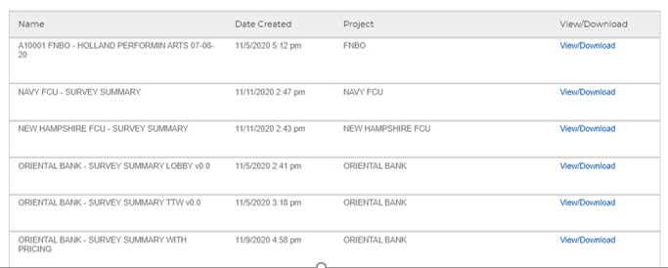
With info: Item Name/Number, Date, Description, and Link.
Link will allow the customer to download the item purchased via that link, here is an example: https://5702210-sb1.secure.netsuite.com/c.5702210_SB1/site/assets/Downloads/000025E.pdf
If list is empty, we will show: “No recent downloads” as message or a customizable one.
We will retrieve all this data from a saved search which will contain sales order, with items related that are only downloadable items.

Test Case

Test Case 1
- Sandbox.veritaspress.com and Sandbox instance are ready.
  - https://sandbox.veritaspress.com/classically-cursive-ten-commandments-book-2-2nd-ed.html
- In order to see all the download items in NetSuite; navigate to Lists > Accounting > Items.
- Set Filter to “Download Items”
- 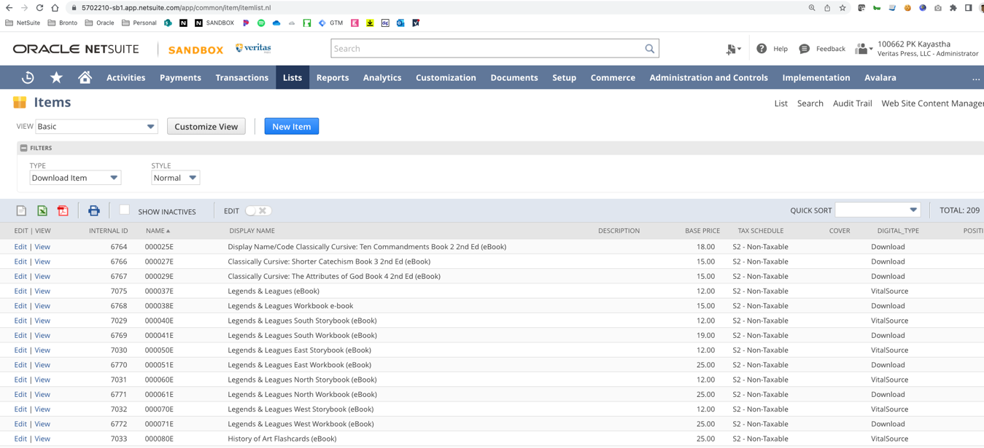

Test Case 2
Here you can see a screen shot of the Saved Search created.
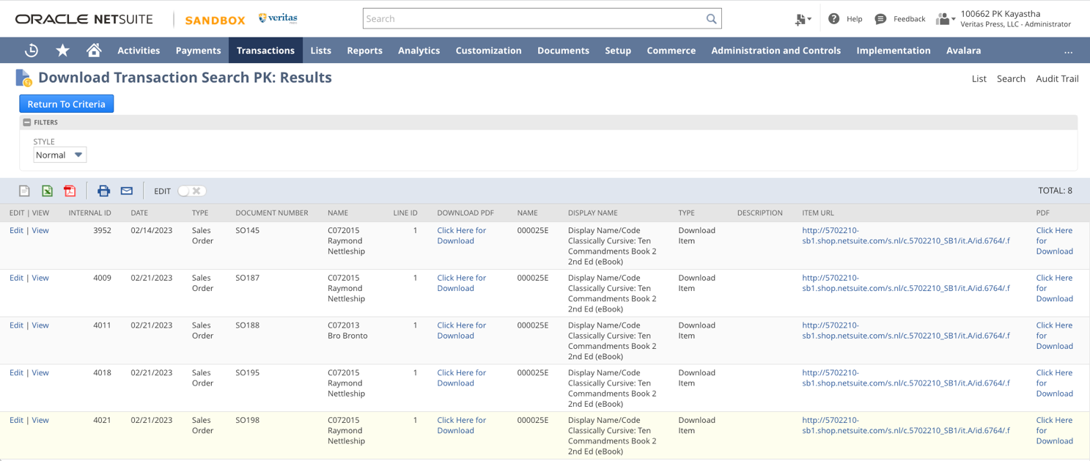
- PLEASE NOTE: The screen shot attached here is showing 1 item. This item is a Download Item. It is called 000025E.
- To see more, we simply need to add the other Download items to the filter criteria. This is something we can do, or the client is comfortable doing in real time prior to Going live.

Assumptions
This section will be primarily for digital download items their customers would purchase through the SuiteCommerce webstore. Purchases cannot be limited to web store. Phone orders must also apply.
Customer will be setting up all of their download items. This includes the field for PDF download where they will enter the hyperlink of the file that is stored in the file cabinet. Why is this necessary? Items in the file cabinet are downloadbable and urls are managed there. We rejected this design as it will not meet our needs.
None of the following makes sense to me. We purchased the software management module so this would not be required. The stock, out of box "My downloads" shows all customer downloads. If my ask to show item name and not just file name is driving this design we can drop that request. Based on what I'm reading here, You are not leveraging the software management module features and relying on an earlier design that has been rejected.

Customer will provide a saved search with all the sales order with Download Items for every client.
Customer will update the Saved Search with their Download Items.
Guidance will be provided to Customer to update the Saved Search.
All information to be published on My Downloads section to be pulled from records in NetSuite instance.
Filename will be same as the item name Not true
Filename must be in same location ?
Filename must always be a .PDF file Definitely not true - pdf, mp3, zip are all being sold
Filename must always be 1 file per item Not true. We sell multiple mp3s on a single item
Each customer must not have more than 100 downloadable items. Why should this be a limitation?

Acceptance
Oracle + NetSuite Professional Services and Customer are in agreement that the information documented above is accurate and representative of the customer’s business needs. This document will act as the basis for all subsequent implementation activities.
Delivery Date: 06/12/2019
Document Version: 1.0

Oracle + NetSuite Acceptance
Action | Name | Title | Signature | Date
Accepted By |  | Project Manager
Accepted By |  | Consultant

Customer Acceptance
Action | Name | Title | Signature | Date
Accepted By |  | Project Manager

